First-Person Storytelling Exercise for Law Students*
*With special thanks to The Moth for the inspiration
Michael J. Steinberg, Director
Civil Rights Litigation Initiative
University of Michigan Law School
mjsteinb@umich.edu / 734-615-2407

- Discussion of the importance of storytelling
- From beginning, human beings have communicated through stories
- Whether used to advocate, entertain, or inform, stories are a powerful tool
- Good lawyers must know how to tell stories about their client that resonate
- To attain your dream job, you have to be able to tell your own story in an interview

- Difference between third-person storytelling (i.e., telling client’s story from their point of view) and first-person storytelling (i.e., telling your own story).

- This exercise involves first-person storytelling – similar to stories told on the Moth Stage. See www.themoth.org.
- Purpose is to:
- Give student an opportunity to practice public speaking without notes;
- Give students an opportunity to reflect about themselves, their development, and their values (classic clinical pedagogy);
- Allow students to learn more about their classmates.
- Although the story the students will be telling is about themselves, the principles of good storytelling are universal and are easily applied to lawyering.

- Teach the elements of a strong story:

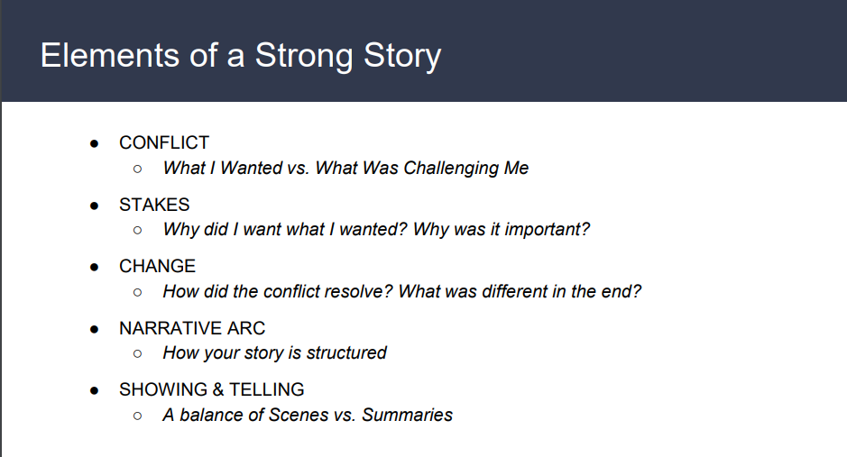
- Teach the narrative arc of a good story

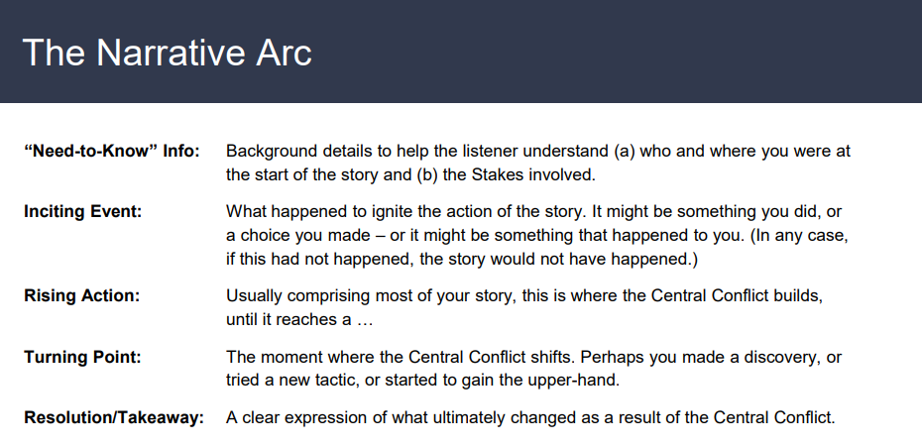

- Show a video of a Moth story. There are dozens of stories available on The Moth’s YouTube Channel. Here is another story* told by some clinical professor (me) at a Moth Mainstage about a humorous case he litigated when he was an ACLU attorney.
(*https://www.youtube.com/watch?v=9Yc-IYEqxPQ)

- Analyze the story using the list of the elements of a good story
- What was the conflict and what were the stakes?
- How did the conflict resolve?

- Did the story fit into the narrative arc as described above?
- What was the “need-to-know” info?
- The inciting event?
- Rising action
- Turning point?
- Resolution?

- Give students a homework assignment to come up with their own first-person story along a theme. The story must be true, it must not be more than 5 minutes long (or so), and it must be told without notes. They should refer to the “Elements of a Story” and “Narrative Arc” slides when developing the story. Reemphasize that the story must have stakes, a conflict, and a resolution, and the story must be about the storyteller. Encourage the students to be vulnerable; stories that reveal the storytellers’ vulnerabilities are usually the best stories. Assure them that this exercise is intended to be fun and they will have the friendliest audience possible.
Here are some options that you may use for story themes. They can interpret the prompts anyway they like. The students need not feel compelled to use the actual word(s) in the prompt.
- Turning point
- Leap of faith
- Destiny
- Influence
- Out of the Blue
- Firsts
- Lost and Found
- Fight the power
- (For social justice/civil rights clinics) What experience(s) in your life made you want to devote your life to working for social justice
I encourage students to write down their story and edit it. Then I encourage them to make an outline of the story. It’s good to memorize the first sentence and the last sentence, but there’s no need to memorize every line of the story. Each time a story is told, it’s a little different and that’s okay.
Encourage students to practice their stories when they have down time: when they go on a walk or jog, when they are in the car/bus, when they are in the shower, etc. Then they should practice in front of friends or in front of the mirror without notes.

- Throughout the semester, towards the end of your seminar class, have one or two students tell their stories. (I have them stand up to tell the story behind a podium, but that’s optional.)

The other students should be supportive/encouraging and clap loudly before and after the story. Save some time for positive feedback from the students and you. Talk about certain parts of the story resonated with you. Name the stakes, conflict, and resolution. I have found that this type of storytelling is a wonderful way to build community within your class.
Note: Although not necessary for this exercise, I would highly recommend The Moth’s new book, How to Tell a Story, available here. It was on New York Times Best Sellers List.

