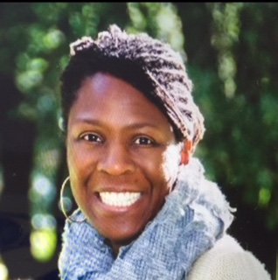

Demarris Evans teaches mindfulness through the lens of healing and human potential. She has worked as a trial attorney at the San Francisco Public Defender’s Office for the last 20+ years, and in this capacity, Demarris has represented clients in the Clean Slate Program, Collaborative Court Programs, including Drug Court and Community Justice Court, Juvenile Delinquency, and the Felony Unit, including handling all aspects of felony case litigation. In addition to other assignments, she is currently working as the Racial Justice and Equity Attorney for the San Francisco Public Defender’s Office as well as the Chairperson of the Racial Justice Committee. Demarris was an instructor in the Criminal Justice Department at the University of Phoenix for several years. She is also a member of the San Francisco Bar Association’s Criminal Justice Task Force where she chairs the Bias and Policing Subcommittee. She previously served on the San Francisco Bar Association’s Judiciary Committee. She has served on the Attorney Panel of California Bar Examination Graders for over a decade. She is a graduate of the Gerry Spence Trial Lawyers College and is a graduate of the Warrior One Mindfulness in Law Teacher Training Program of 2016. Demarris has been practicing mindfulness since the late 1990’s, and has sat numerous silent, multi-day retreats. Demarris is currently enrolled in the Dedicated Practitioner Program at Spirit Rock Meditation Center and Communities Rizing Yoga and Meditation Teacher Training Program for People of Color. Demarris has led numerous Mindfulness trainings, and currently leads a weekly sitting meditation practice at the San Francisco Public Defender’s Office. She is also on the Board of Directors for the Mindfulness in Law Society and is the Head of the Criminal Law Division.

